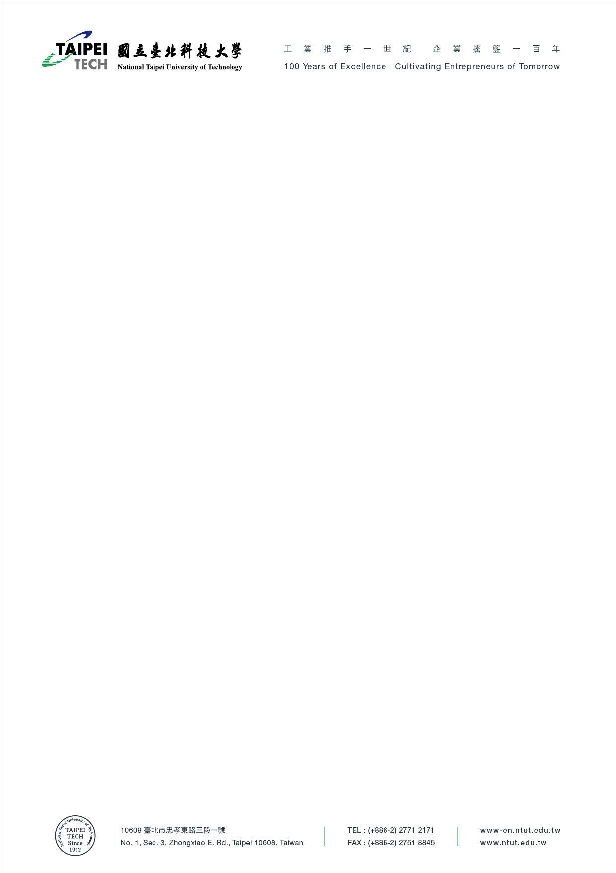

Taipei, December 10th, 2022

To whom it may concern,

This letter hereby confirms **Mr/Ms. ___________** (born on December 10th, 1999), from (Country Name), is currently enrolled as a Semester Exchange Student at the faculty of (Department Name), National Taipei University of Technology (Taipei Tech). The duration of her stay is from 2022.09.01 to 2023.08.31.

If there is any question about this matter, please do not hesitate to contact us.

Best regards,

**Prof. Ryan Sheng-Ming Wang**

Office of International Affairs

National Taipei University of Technology

ryan5885@mail.ntut.edu.tw

(02)2771-2171 #6521