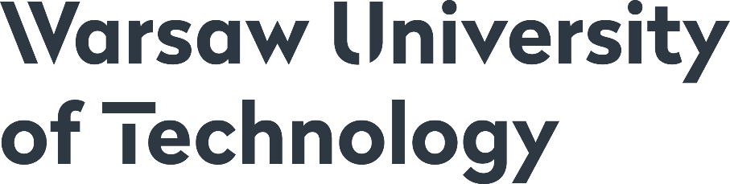
FACTSHEET FOR BILATERAL EXCHANGE CANDIDATES

ELIGIBILITY
Students must be enrolled in full-time undergraduate or graduate programmes at their Home Universities that undersigned an agreement on student exchange with Warsaw University of Technology. Candidates for student exchange have to be officially nominated by their Home University. The other requirements and specific terms of student exchange (exchange period, financial conditions, etc.) are regulated by the bilateral agreement between the Home and Host Universities. For details please contact your International Office.
STUDY PROGRAMMES
Currently, full programmes of studies in English are offered by 15 Faculties of Warsaw University of Technology. Full list is available at https://www.cwm.pw.edu.pl/en/Education-programmes/Bilateral-exchange/Incoming-students
Students can choose subjects offered by one Faculty. One semester workload is approximately 30 ECTS.
NOMINATION PROCEDURE
Home University Exchange Coordinators are kindly asked to complete the nomination sheet. There is no separate deadline for that. Completed nomination sheet can be send along with the candidates' application documents.
The form is available at https://www.cwm.pw.edu.pl/en/Education-programmes/Bilateral-exchange/Incoming-students
APPLICATION DOCUMENTS
The complete application packet of a candidate consists of:
- Application form
- Learning Agreement (approximately 30 ECTS credits is required per semester)
- Confirmation of proficiency in English (at least B2 level). A list of approved certificates is available at https://www.students.pw.edu.pl/Resources/Application-Glossary/English-Proficency Certificates issued by the Home University are also accepted.
- Copy of passport - page containing personal data
- Transcript of Records
Forms are available at https://www.cwm.pw.edu.pl/en/Education-programmes/Bilateral-exchange/Incoming-students
The abovementioned documents do not apply to candidates applying to the Faculty of Power and Aeronautical Engineering who are obliged to register in the Faculty's on-line system. Link to the system will be provided individually to candidates nominated by their Home University. Please note that the deadlines may differ from the general ones.
APPLICATION PROCEDURE
- Candidates must obtain a formal approval from the Home University. Applications will be accepted only on the basis of official nominations from a Home University.
- A complete documentation of candidates should be sent by the Home University International Office to the Centre for International Cooperation of the Warsaw University of Technology. Scanned copies of application documents are sufficient. The deadlines for submitting applications are:
INTAKE | APPLICATION DEADLINE
Semester 1 (October - February) | 1st of May
Semester 2 (February - June) | 15th of October
ACCOMODATION
Please note that all WUT dormitories are located off the campus.
Candidates will be able to apply for dormitory. They will have to submit their applications through Online Accommodation System. Detailed information will be sent directly to candidates.
POLISH COURSES
If you wish to learn Polish during your exchange period at WUT, please officially declare it in your Learning Agreement.
ACADEMIC CALENDAR
SEMESTER | DURATION
Semester 1 | October 1st – mid-February
Semester 2 | 3rd week of February – June 30th

MORE INFORMATION & CONTACT
https://www.cwm.pw.edu.pl/en/Education-programmes/Bilateral-exchange/Incoming-students

