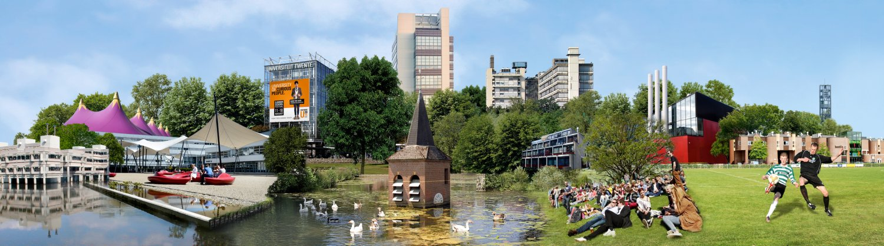
Institutional data  Website  Erasmus code  PIC code  Organization ID | University of Twente | P.O. Box 217 | 7500 AE Enschede, The Netherlands | ECHE  www.utwente.nl/en/  NL ENSCHED01  999900833  E10209138
Contact information | Scholarship Office & IRP Team  Institutional Erasmus Coordinator | e-mail: Miranda Bönhke | Phone: +31 (0)53 487 4368  Administrator Exchange Agreements | e-mail: Silvia Kampherbeek  International Event Support Officer | International Student Events | e-mail: Liz Louden  Let’s Go Fair| email: Let’s Go  Faculties | Departmental Exchange Coordinators
Portals for inbound/outbound  FAQ | Inbound incoming-exchange@utwente.nl | Outbound Studyabroad@utwente.nl  FAQ Exchange students
Nomination | Mobility Online | Partner nomination manual | Questions
Links | Academic Calendar  Course catalogue  Credit & Grading System  Disabilities  English Language Requirements  Exchange packages  Exchange Deadlines  Housing | Insurance | Visa & Residence Permit

