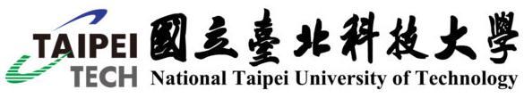

Agenda for
visiting
National Taipei University of Technology

DATE: | NUMBER OF GUESTS:
CHAIRMAN: | LOCATION:
LIAISON: | CONTACT:
Attendees of :

Attendees of National Taipei University of Technology (Filled by Taipei Tech):

Contact Person:
Americas
Ms. Anita Lin Wendt, Office of International Affairs
國際事務處 林瑋軒小姐 a.l.wendt@ntut.edu.tw

Europe
Ms. Jennifer Kao, Office of International Affairs
國際事務處 高惟珍小姐 jnfkao@ntut.edu.tw

Asia:
Mr. Eric Su, Office of International Affairs
國際事務處 蘇世文先生 sswwhite@ntut.edu.tw

Africa:
Ms. Annie Kuan, Office of International Affairs
國際事務處 關曉雯小姐 anniekuan@ntut.edu.tw

ITINERARY |  | LOCATION
00:00-00:00 | Arrival | Main Gate at No. 1,  Sec. 3, Zhongxiao E. Rd.

